**Discussion topics for the integrate and fire model, and its extensions.**

1. Describe the main components of the IF model. Draw it (in some way).
   1. Dv/dt = I/C
   2. I= current
   3. C= capacitance
   4. Resets when reaches specific voltage
   5. Cookie cutter AP spikes with a linear rate of increase
   6. 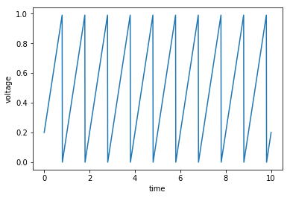
2. Describe the main components of the LIF model. Draw it (in some way).
   1. 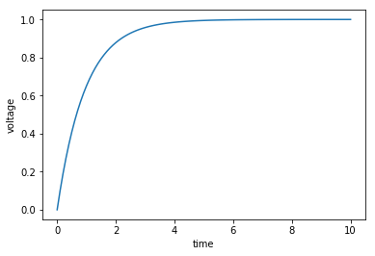
   2. Voltage dependent decay
   3. Tau: membrane time constant, helps determines decay rate
   4. R: resistance, increase in R would create more pressure which increases membrane potential
   5. I: applied current
3. Describe the differences and similarities between the IF and LIF models.
   1. Both integrate the input
   2. LIF: non-linear increase in voltage because the decay rate is voltage dependant
4. The IF model is meant to mimic a neurons activity. Describe what is realistic about the IF model? What is unrealistic?
   1. Realistic: Generates spikes and resets, integrates inputs
   2. Unrealistic: no hyperpolarization phase, no leak.. , in reality voltage does not increase at a constant rate, ion channel conductivity Is voltage dependant, no threshold for AP generation. No potassium ?
5. Describe the roles of the IF model parameters Vreset and Vthreshold.
   1. V_reset = voltage it will be reset to. Resting membrane potential
   2. V_threshold = max voltage which tells system to reset. Threshold of Voltage gated sodium ions
6. Consider the IF model. Sketch voltage (V) versus time (t) for a small input current, for a large input current.
   * 1. Small input current:
     2. 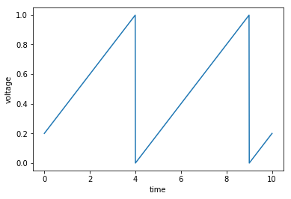
     3. Large input current:
     4. 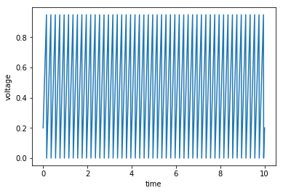
   1. How does an increase in capacitance (C) impact the dynamics?
   2. 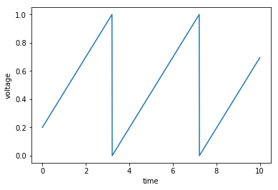
   3. Can you interpret this physically?
      1. slower increase, requires more input to have the same response
7. Consider the LIF model. Sketch voltage (V) versus time (t) for a small input current, for a large input current.
   * 1. Small input:
     2. 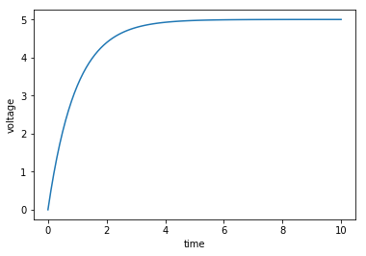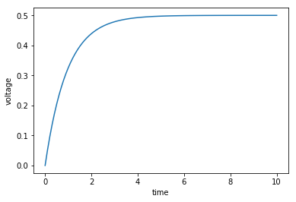
   1. How does an increase in the resistance (R) impact the dynamics?
      1. 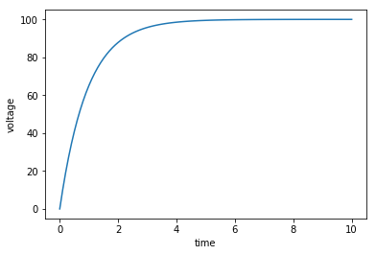
      2. Increase the equilibrium
   2. How does an increase in the capacitance (C) impact the dynamics?
      1. 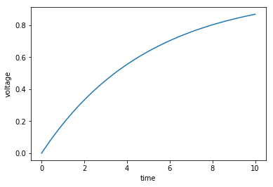
      2. Makes it take way longer to reach equilibrium because of a higher decay rate. Much more leaky. Large tau like having no myelination.